# Lab-12: PHP CRUD Operations

# QUESTION:-

Perform View, Update, and Delete of at least 2 different types of data/entities of your semester project.

## 1. Create a MySQL DB in phpMyAdmin for your Semester Project/BDP

### 1.1.1 Bookings:-

CREATE TABLE bookings ( id INT AUTO_INCREMENT PRIMARY KEY, venue_id INT NOT NULL, booked_by VARCHAR(255) NOT NULL, date DATE NOT NULL,

FOREIGN KEY (venue_id) REFERENCES venues(id) ON DELETE CASCADE);

### 1.1.2 Venue:-

CREATE TABLE venues ( id INT AUTO_INCREMENT PRIMARY KEY, name VARCHAR(255) NOT NULL, capacity INT NOT NULL);

### 1.1.3 Output:-

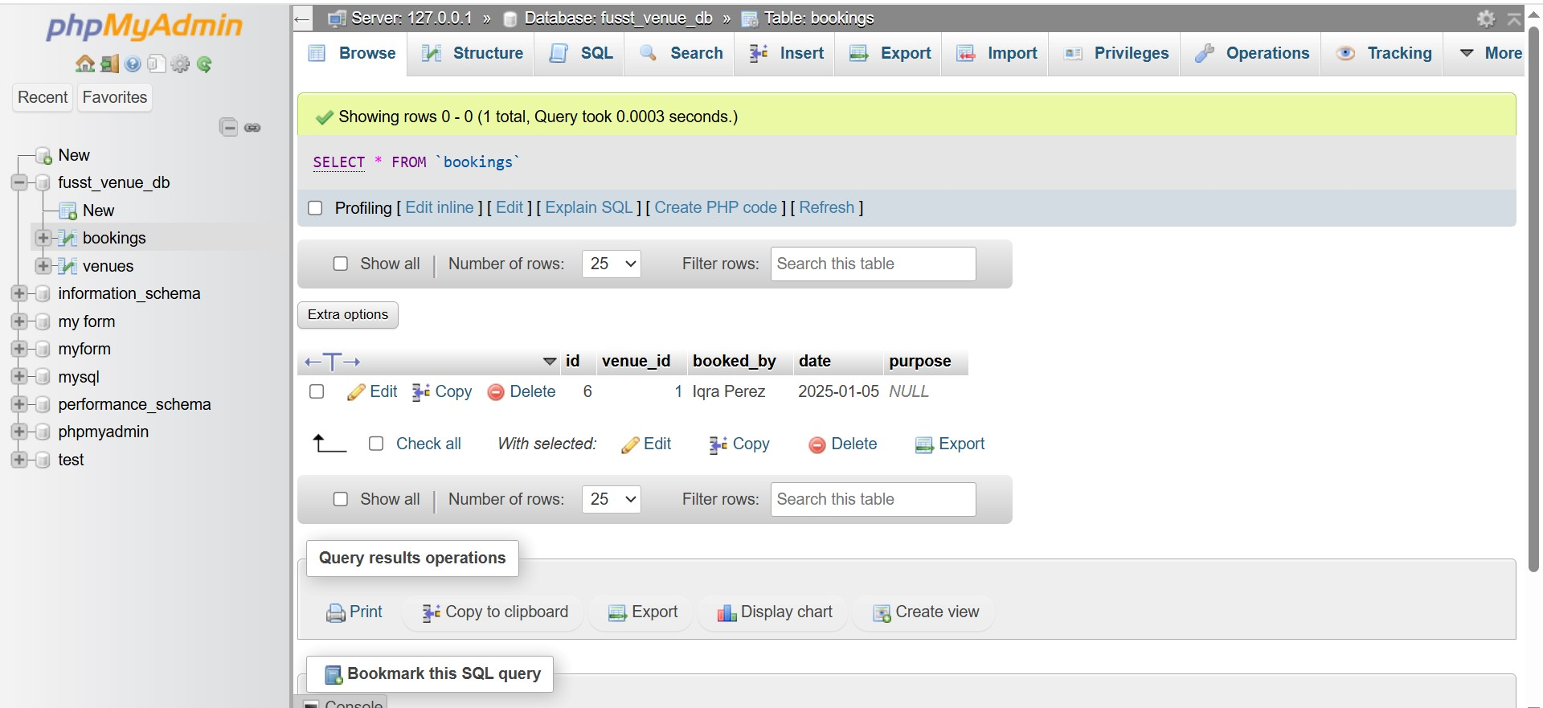

## 2. .PHP:-

### 2.1.1 create_venue:-

<?php include 'db.php'; if ($_SERVER['REQUEST_METHOD'] == 'POST') {

$stmt = $conn->prepare("INSERT INTO venues (name, type, capacity) VALUES (?, ?, ?)");

$stmt->bind_param("ssi", $_POST['name'], $_POST['type'], $_POST['capacity']);

$stmt->execute(); header("Location: index.php");}?> <!DOCTYPE html>

<html><head>

<title>Add Venue</title>

<link href="https://cdn.jsdelivr.net/npm/bootstrap@5.3.0/dist/css/bootstrap.min.css" rel="stylesheet"></head>

<body class="bg-light">

<div class="container mt-5">

<h2>Add New Venue</h2>

<form method="POST">

<div class="mb-3">

<label class="form-label">Name</label>

<input type="text" name="name" class="form-control" required></div>

<div class="mb-3">

<label class="form-label">Type</label>

<input type="text" name="type" class="form-control" required></div>

<div class="mb-3">

<label class="form-label">Capacity</label>

<input type="number" name="capacity" class="form-control" required></div>

<button type="submit" class="btn btn-primary">Add Venue</button>

<a href="index.php" class="btn btn-secondary">Cancel</a>

</form></div></body></html>

#### Output:-

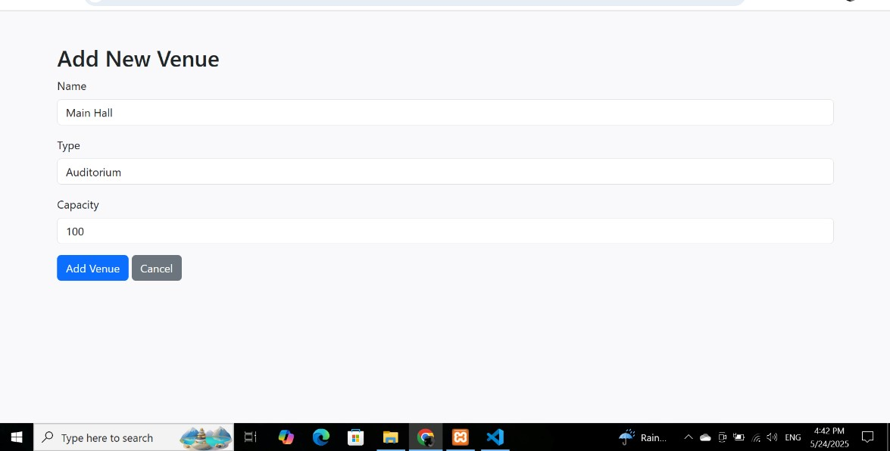

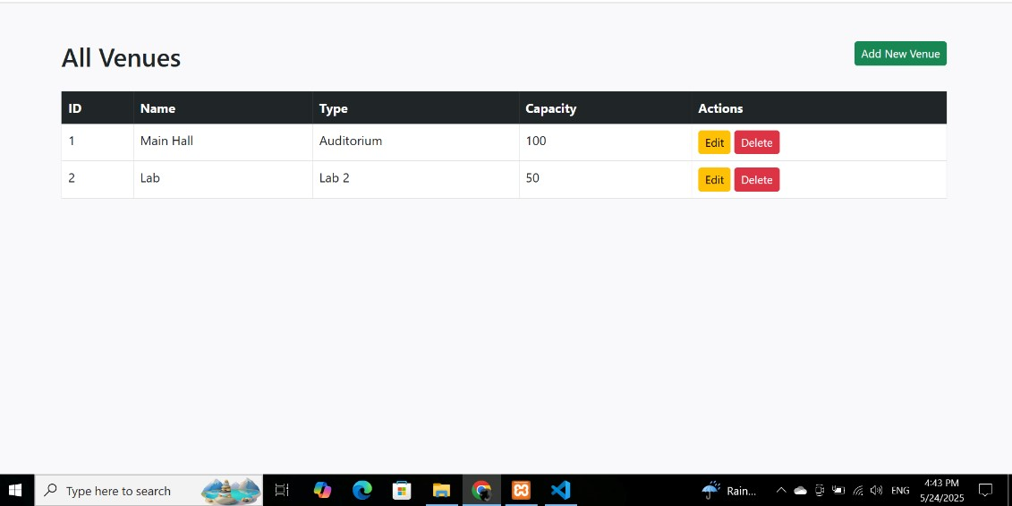

#### 2.1.2 create_booking:-

<?php

include 'db.php';

if ($_SERVER['REQUEST_METHOD'] == 'POST') {

$stmt = $conn->prepare("INSERT INTO bookings (venue_id, booked_by, date) VALUES (?, ?, ?)");

$stmt->bind_param("iss", $_POST['venue_id'], $_POST['booked_by'], $_POST['date']);

$stmt->execute(); header("Location: bookings.php");}

$venues = $conn->query("SELECT * FROM venues");?>

<!DOCTYPE html>

<html><head>

<title>Add Booking</title>

<link href="https://cdn.jsdelivr.net/npm/bootstrap@5.3.0/dist/css/bootstrap.min.css" rel="stylesheet"></head>

<body class="bg-light">

<div class="container mt-5">

<h2>Add Booking</h2>

<form method="POST">

<div class="mb-3">

<label class="form-label">Venue</label>

<select name="venue_id" class="form-control" required>

<?php while($v = $venues->fetch_assoc()): ?>

<option value="<?= $v['id'] ?>"><?= $v['name'] ?></option>

<?php endwhile; ?></select></div>

<div class="mb-3">

<label class="form-label">Booked By</label>

<input type="text" name="booked_by" class="form-control" required></div>

<div class="mb-3">

<label class="form-label">Date</label>

<input type="date" name="date" class="form-control" required></div>

<button type="submit" class="btn btn-primary">Add Booking</button>

<a href="bookings.php" class="btn btn-secondary">Cancel</a>

</form></div></body></html>

##### Output:-

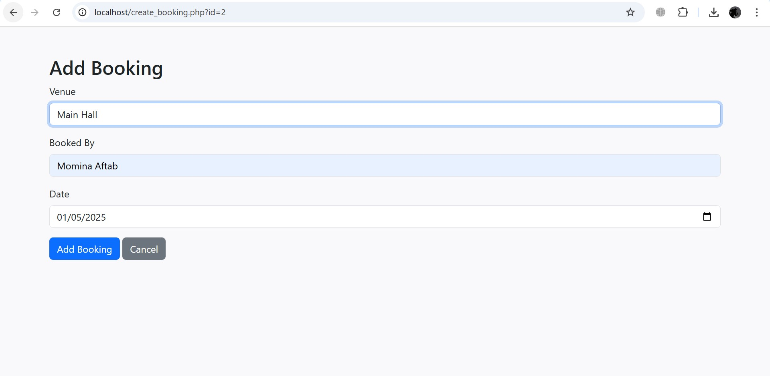

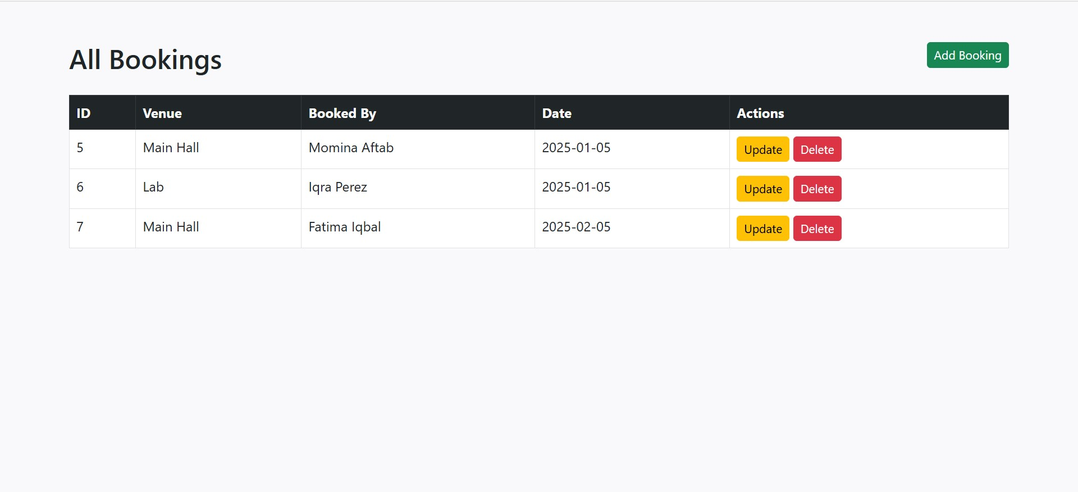

#### 2.1.3 bookings:-

<?php include 'db.php'; ?>

<!DOCTYPE html>

<html><head>

<title>All Bookings</title>

<link href="https://cdn.jsdelivr.net/npm/bootstrap@5.3.0/dist/css/bootstrap.min.css" rel="stylesheet">

</head>

<body class="bg-light">

<div class="container mt-5">

<h2 class="mb-4">All Bookings <a href="create_booking.php" class="btn btn-success btn-sm float-end">Add Booking</a></h2>

<table class="table table-bordered table-hover">

<thead class="table-dark">

<tr>

<th>ID</th><th>Venue</th><th>Booked By</th><th>Date</th><th>Actions</th>

</tr></thead><tbody><?php

$sql = "SELECT b.id, v.name as venue_name, b.booked_by, b.date FROM bookings b JOIN venues v ON b.venue_id = v.id";

$result = $conn->query($sql); while($row = $result->fetch_assoc()): ?>

<tr>

<td><?= $row['id'] ?></td>

<td><?= $row['venue_name'] ?></td>

<td><?= $row['booked_by'] ?></td>

<td><?= $row['date'] ?></td>

<td>

<a href='edit_booking.php?id=<?= $row['id'] ?>' class='btn btn-warning btn-sm'>Update</a>

<a href='delete_booking.php?id=<?= $row['id'] ?>' class='btn btn-danger btn-sm' onclick="return confirm('Are you sure?')">Delete</a></td></tr>

<?php endwhile; ?></tbody> </table></div></body></html>

### Output:-

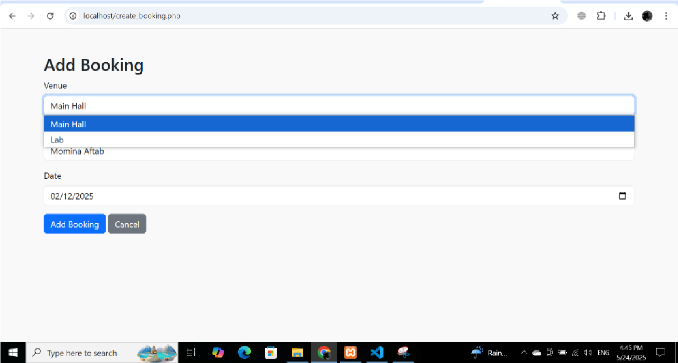

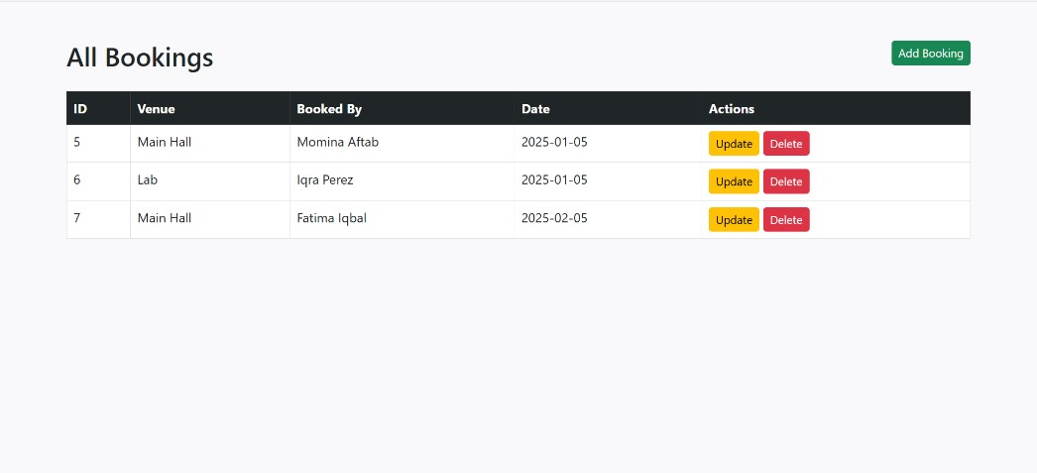

#### 2.1.4 delete_booking:-

<?php

include 'db.php'; if (isset($_GET['id'])) {

$stmt = $conn->prepare("DELETE FROM bookings WHERE id = ?");

$stmt->bind_param("i", $_GET['id']);

$stmt->execute();} header("Location: bookings.php");?>

##### Output:-

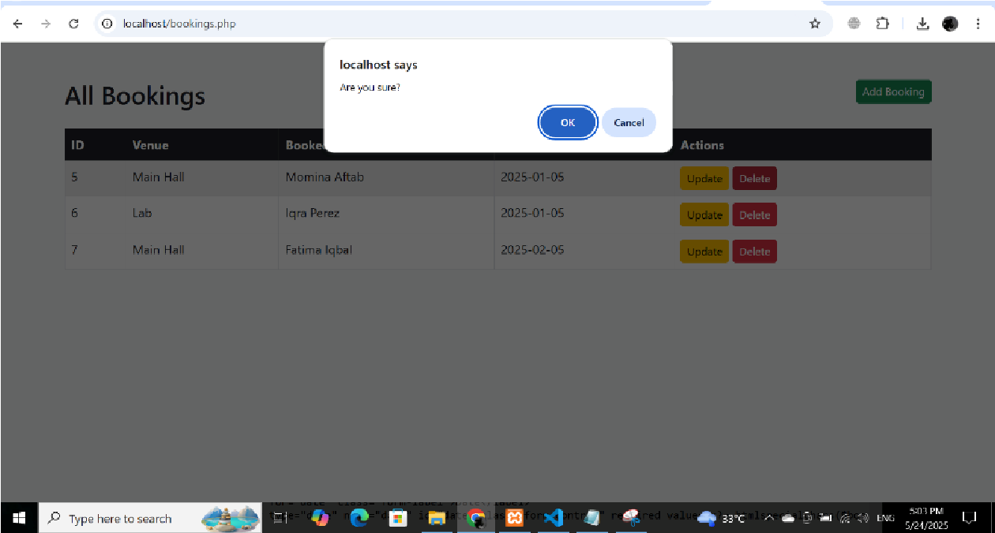

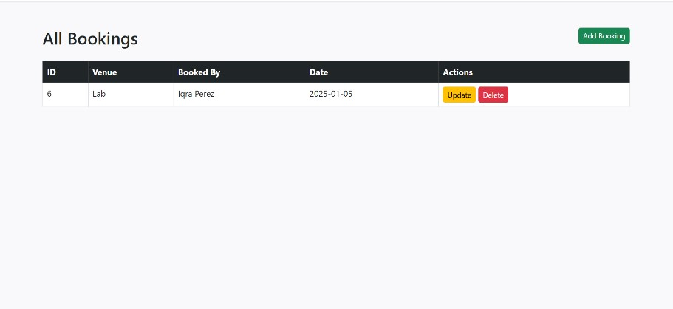

#### 2.1.5 edit_bookings:-

<?php

include 'db.php'; if (!isset($_GET['id'])) { header('Location: booking.php');

exit;}

$id = intval($_GET['id']);

$venuesResult = $conn->query("SELECT id, name FROM venues"); if ($_SERVER['REQUEST_METHOD'] === 'POST') {

$venue_id = intval($_POST['venue_id']);

$booked_by = $conn->real_escape_string($_POST['booked_by']);

$date = $conn->real_escape_string($_POST['date']);

$updateSql = "UPDATE bookings SET venue_id = $venue_id, booked_by = '$booked_by', date = '$date' WHERE id = $id"; if ($conn->query($updateSql) === TRUE) { header('Location: booking.php');

exit;

} else {

$error = "Error updating booking: " . $conn->error;}}

$sql = "SELECT * FROM bookings WHERE id = $id";

$result = $conn->query($sql); if ($result->num_rows !== 1) { header('Location: booking.php');

exit;}

$booking = $result->fetch_assoc();?>

<!DOCTYPE html>

<html><head>

<title>Edit Booking</title>

<link href="https://cdn.jsdelivr.net/npm/bootstrap@5.3.0/dist/css/bootstrap.min.css" rel="stylesheet"></head>

<body class="bg-light">

<div class="container mt-5">

<h2>Edit Booking</h2>

<?php if (!empty($error)): ?>

<div class="alert alert-danger"><?= $error ?></div>

<?php endif; ?>

<form method="POST">

<div class="mb-3">

<label for="venue_id" class="form-label">Venue</label>

<select name="venue_id" id="venue_id" class="form-select" required>

<?php while ($venue = $venuesResult->fetch_assoc()): ?>

<option value="<?= $venue['id'] ?>" <?= ($venue['id'] == $booking['venue_id']) ? 'selected' : '' ?>>

<?= htmlspecialchars($venue['name']) ?>

</option>

<?php endwhile; ?></select></div>

<div class="mb-3">

<label for="booked_by" class="form-label">Booked By</label>

<input type="text" name="booked_by" id="booked_by" class="form-control" required value="<?= htmlspecialchars($booking['booked_by']) ?>"></div>

<div class="mb-3">

<label for="date" class="form-label">Date</label>

<input type="date" name="date" id="date" class="form-control" required value="<?= htmlspecialchars($booking['date']) ?>">

</div>

<button type="submit" class="btn btn-primary">Update Booking</button>

<a href="booking.php" class="btn btn-secondary">Cancel</a>

</form></div></body></html>

##### Output:-

